**New Syllabus NESA Questions:**

1) C

2) A

3) C

4)

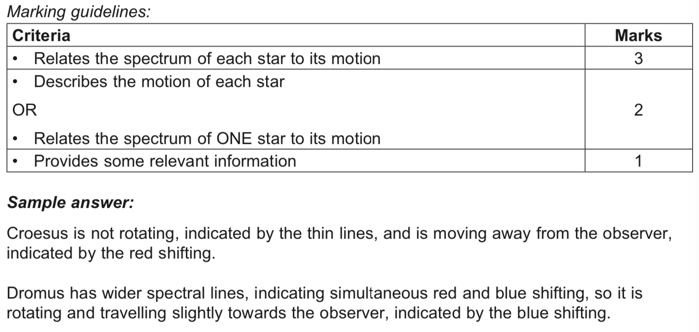

**Past HSC Questions**

**2015:**

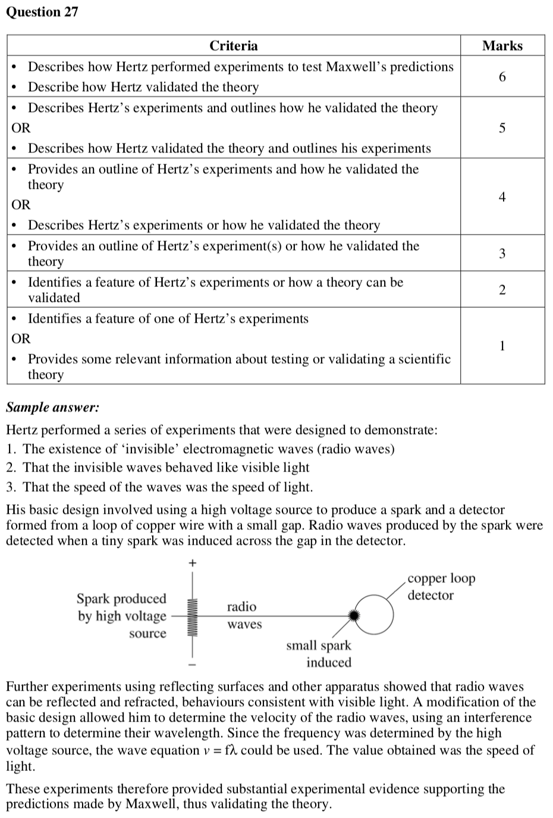



**2014:**

16) A

**2013:**

5) D

**2010:**

14) C

**Before 2009 there were no answers given for short answer please use a book like Excel Physics**

**2008:**

10) A

**2005:**

11) B

**2003:**

12) D

14) D